when I first read the mail about selecting modules and saw the description of 1028 I was very excited to take up this module and challenge myself with something tricky and useful

I had made a few basic projects using python and learned about the language. When I got a mail that I was selected for 1028 it made me very happy and then I started with selecting my projects first and i got the allotment of my project. I was a bit scared after seeing the description of the project as it had a few things like git hub flask and python anywhere to which i was completely new to.

I started off my journey by seeing a complete tutorial of git hub and learning how to use GitHub at the very first and was my first step towards the learning process. Initially, I had a few problems with GitHub like using it with vs code I faced a few errors which took time to overcome and start using GitHub fully

after git hub I took a basic tutorial on flask on how to create a basic flask website after that it caught my interest and I started building a web app using flask which had basic services like login and navigating through the navbar

during this, I faced several issues that I couldn't debug like linking the SQLAlchemy to the vs code and creating a .db file

I also learned how to make python packages and along with that I added templates of HTML to the website and took a basic idea of using jinja syntax

WEDNESDAY 19th January

We had our first meeting for which I was very nervous and scared as I had not understood my project very clearly and did not even have experience in flaks before the meeting

I was also not very sure about the diary so I had written it down instead of writing it digitally so I was not able to present it.

The first meeting was very helpful for me as I got a good idea about the project I am working on and I knew where I could start from

now I have a very good idea about how my initial pages of login and forms should be like starting with creating a basic website where I can navigate through the web app

I also got to know about a subscription app called notion from which I take influence

THURSDAY 20th January

I started working with forms in Flask and explored various new terms like wtforms and importing diffrent feilds using wtforms like SubmitField and others which are very convinient i also started looking at the jinja syntax and its uses which will help in using flask and implement logic code. Today i also tried to create a form for sign in and password

Friday 21th January

I now started working with templates directory where i created a basic html which will have common asthetics for all the navigated tabs and using jinja syntax i used to create various more templates rather than writing the html code again and again now i have created 4 diffrent templates using one base template and jinja syntax where you can easily navigate through the routes using the navbar and used a function called {{ url_for('home_page')}} using jinja syntax .

Monday 24th January

I now wanted to add the submitted details of the form to a database but i wasnt able to do so , i Have been working on finding a debug solution for the same i also refereed many different solutions and tutorials but not able to do so, alternately i tried to store the information in a python list which could work well for less number of data but ddefinetly if i could work with a database will be better. I also tried to learn how to send mails using the STMP service which might be helpful for us in the future.

I will be traveling back to Belfast on 25th and will reach Belfast on 26th January so i have asked John to host my meeting on a later date and our weekly meeting is now scheduled on 27th Thursday 1pm

27th January-Thursday

I had a very productive meeting with John,now quite a few things were more clear in my mind and i knew what are my immidieate short term goals and also got a few links from john which will clear my database doubts and along with that i also guided to the correct direction of How-to-guide.

In this particular meeting with John he asked me to focus on Jinja Syntax and the database connection, he also sent me a link of blog that can be refrenced from.

So I have added a tab for Databases and Jinja with each and every step and how to use them to my how to guide.

28th January-Friday

John had asked me to follow a blog and use that to get myself clear with pythonanywhere and i started working with that blog, the blog was about creating a simple website and using git in pythonanywhere

https://blog.pythonanywhere.com/121/

I created a basic flask application using this blog,this blog was a very excellent place to solve all my problems and i finally was able to work with databse and was sucessful entering the database and access it using pythonanywhere's SQL console

along with cracking through my database issue i also had a very good hands on experience with pythonamywhere and i finally can deploy my code from vs to here.

29th January

I had to move my code from VS CODE to pythonanywhere and i started exploring pythonanywhere, i started with shifting my routes then my basic template and checking if it would work and after a few changes#

my code started working in pythonanywhere and i was able to get the similiar base 1 pmsite working.after the base i imported my market zone and then the fo rms, i had made a very silly mistake while importing tIe form which took immediatey time

for debbuging and i finally found out that i had used the app.config['SECRET KEY '] which is essentiaI for forms to get working.

31st January

After i was able to use my code on pythonanywhere, i was going to put details of forms into a database and i was going to connect

the datbase but when i tried to do so i got a very silly error and i was not able to get it working then n finally messaged John and seeked his help again

and aparently i was doing a very silly mistake and had not selected the correct path while using ipython. I was so irritated with databases but now finally it is working

After that i finally strated with my how to guide and started making a mindmap of how i will go about the guide and making the html.

1st February

I finally started working on the How-to-guide and I was planning to make a web page with each and every step from knowing and understanding what a flask framework is, so I decided to start writing about the flask framework and its definition, this guide is targeting various types of people and new beginners can be one of them too so it was a good idea to start talking about flask.

After Flask, The most important thing is pyhtonanywhere, the IDE which we will be using so I decided to explain pythonanywhere and all the steps to create an account first then the usage and functions of the IDE. This guide could be useful for someone who is used to python but new to pythonanywhere and also the beginners and also for someone who is trying to learn new IDEs and use their existing projects on them. So I started with the steps to create a pythonanywhere account and followed by explaining the features and how pythonanywhere had already created a default app for everyone’s convenience and I also explained the lines of the code for beginners and people new to the flask.

After this I added a page about @app.routes as no one wants their website to be only a page long and also this was mainly for the beginners with flask to understand how different routes are created on pythonanywhere.

Then I added a tab about HTML templates which provide the beautification of our website so I added a few code snippets and screenshots of bootstrap,HTML and explained how we can create a good look basic aesthetic for our app, In this, I have pasted code and attached all the links everywhere so that newcomers who don’t have much experience with python also can do this with a lot of ease and convenience I have also pasted the links for all bootstrap pages where I have copied the code from and I have also explained each and every line where I have updated/changed the code according to my site,

2nd February

Now I decided to start with a very interesting feature of flask and jinja wherein they can send data to the HTML using a python code this was a very important thing to do as beginners won’t find this very amusing, the people who are new to flask will realize how powerful the jinja and flask is as it saves a lot of their time and reduces the scope of error.

Then I created a page about jinja where I first made a few templates by copy-pasting and finding and making changes and then I asked them to delete all their code and use jinja syntax so that even they should realize that so much of their effort could’ve been done so easily and obviously the people who have used other languages for development would’ve been surprised by how you can create 1000s of pages by just one line of jinja syntax and would be impressed with the power of jinja and flask.

3rd February

After yesterdays long slides I decided to get back on a small topic that I had forgot to look into and that was, the navbar was not functional, I had added a bootstrap navbar but I didn’t link pages to it because there was a better way again using jinja syntax that was better and error-proof as even if you change your route it will still take you to that page as it takes you to the defined function and is called as {{url_for}} this was a very important thing to learn for beginners as well as experienced programmers

After that I wrote about the wtforms which is also a function of flask and told them how to create a page for login, now a days all the webpages have login details so it was a key thing for the beginners to learn and others to learn about the wtforms by flask

Finally, I added the database tab where I clearly explained each and every step with screenshots code snippets and as well as database screenshots where it was key to understand that using databases with python anywhere is so much more convenient to use compared to other IDEs and you can also access the database console

4th February -:

I was now checking my HTML file and the content and also worked on the final touchup of all the tabs once and after I was done with the howto guide I started working on the diary and wrote all the details and was ready to submit and very nervous hope everything goes well.

6th February

I got an email from John regarding my feedback on the HowToguide, He had pointed out my mistakes in there and also wrote everything in detail about the mistakes i have done and the Changes i have to make, i had a motivation to go back and try rectifying all my mistakes to the way John had asked me to so i started working onn them

7th February

Now as suggested by John i took a step back and started to look at my project from the begining and tried to find if i could add a few points to the project or i could add a few things to it and i realised that i could add a few navbar options to it and make it more directing towards my project now.

8th February-18th February

In this period of time I was stuck with google login, I was able to implement it but had a lot of errors in doing the same like authorization was not working properly then I tried to implement this with vs code rather than pythonanywhere, where I was able to add google login very smoothly as I was using a local host , after looking up it turned out that the free version of pythonanywhere has some issues with google login and it was uploaded by a few people on their online forum, I was getting an error of mismatch url but infact the url was exactly same so I also tried implementing this by using something other than oAuthlib which had its own different errors. I think It took me quite a while to implement this and I finally was able to get the login working but for a fact that the logout is still not working so I have to cover a bit of this again but I will prefer to drop this for a while

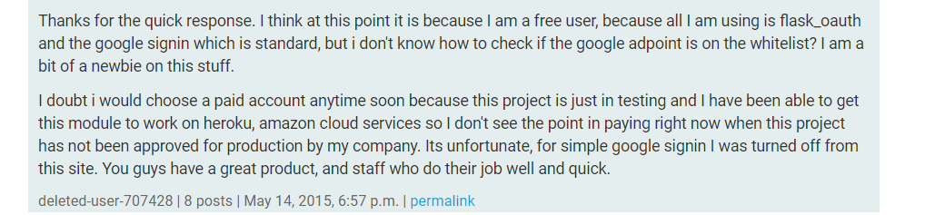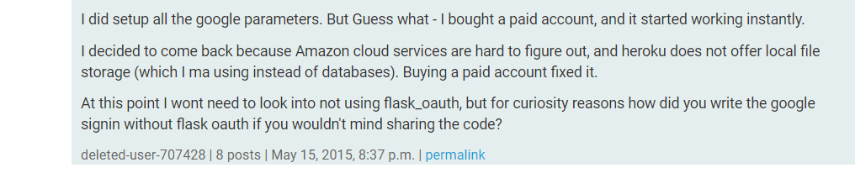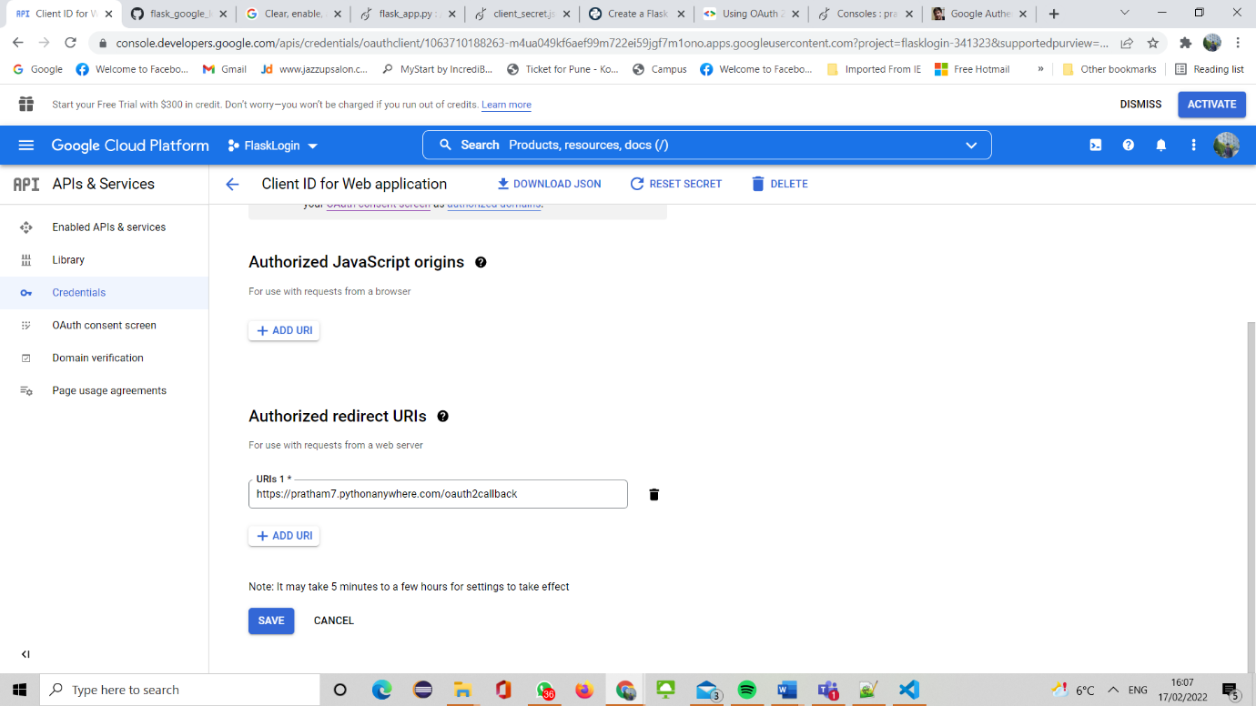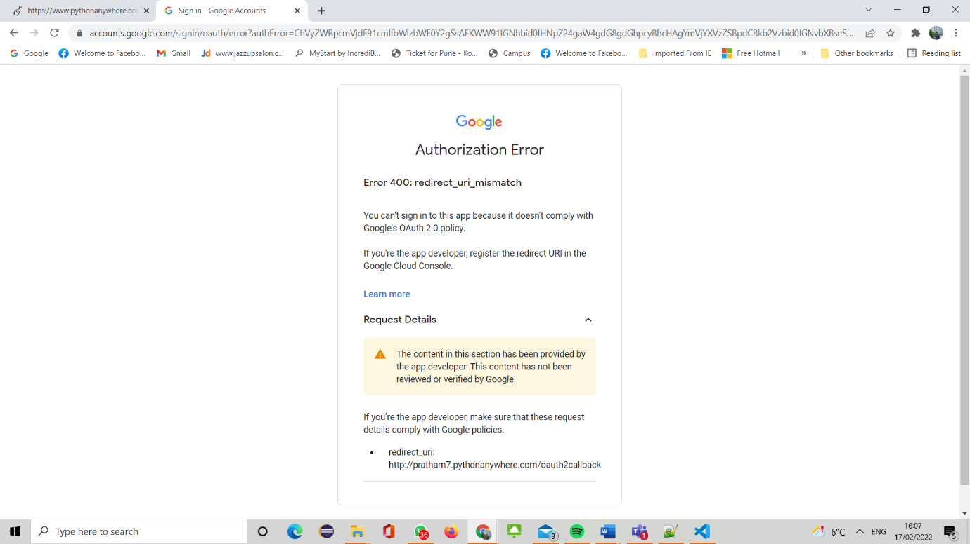

18th February – 23rd February

I started working on PayPal and making subscription plans first I added PayPal checkout using their developer website, which was a smoothly working feature, now I am working on creating a subscription plan and free trial so that I can implement that in the coming days.While doing paypal integration I found an amazing site by paypal called Braintree which has payment options of all different kinds of payment methods available like google pay ,apple pay so I can implement all if it works well.

23Feb-1March

Now I started to deploy all this on pythonanywhere as I had coded all this on VS code I was able to get the google login working but unfortunately the others are not yet working on pythonanywhere I think it is some WSGI server error and I am trying to debug that, I have also raised a query on the forum of pythonanywhere

And I had a meeting with John today he suggested me to start working with the blogpost for the submission and to make a blogpost for a student who would want to either continue my project or just extend the project ahead

Now I've chosen to write a blog post on the things that I've gotten working on pythonanywhere because I still haven't figured out the solution after a lot of debugging.

Advantages of my Blog Post

I'm just embedding my how-to guide in the blog post because it will be very beneficial for my page because I've also included a local login pushing the details to the database and not only that, but I've also created a basic webpage with a working navbar and different @app.routes, so the new developer will save time by simply reading my how-to guide and implementing the code because it contains many concepts like jinja syntax and others that if he or she decides to continue Because doing it on their own will take a long time, more people will read my how-to guide.

Why I think my blogpost will be better than others-

If I would’ve been the one reading this blog post I would be very impressed as other guides/blogposts I read regarding google login make a very ugly page and just show the working of the Google login, but along with google login you also need a normal login and not only that but if you are a new student working in this field as I was it helped you to learn the basics of the flask and creating a good looking website all in one place and you can now continue working on your main project like making an eCommerce website and you will have everything else ready and will save more than weeks of your time.

After working on the blog post I had to make another web page I also had to make changes to the how-to guide as suggested by John in his previous feedback of my project

Mission

The main Mission of this project is that the person can have a basic website with a login and payment system ready and by investing less than a week they can use my source code and start working ahead.

My Mistakes

I have been able to get the login working my PayPal is not yet working so after this I will work on PayPal and get It working

2nd March

After the meeting with John he asked us to add the main mission and vision of our project and how

can someone get It working within the minimum time. And he also said that we should be very clear

in mentioning why is our blog is post-made in the way it is.

3rd March

What makes my guide unique-

1)After a lot of debugging and reading different blogs for implementing the google login, I face a very

**A huge issue with redirect URIs as I was using pythonanywhere and all the tutorials use localhost and there are exemptions for the validation of local hosts but my blogpost Is using pythonanywhere which makes and unique and I would’ve loved to find a blog post or tutorial like this which worked on pythonanywhere**

**Along with this many of the tutorials use OAuth.cred to get the code working but that throws an error in pythonanywhere so I also used an OAuth. google version which will not face any errors in python anywhere And also as mentioned previously I also have included my HowToGuide in my blog post that would be of help as you will get everything in one place**

2)I have also added the links to the places which I referred to to understand the basic fundamentals of OAuth which will be helpful for the people reading the blog to read and then implement the changes so they would understand what they are doing rather than blindly doing it.I have made the changes in the how-to guide the way I was asked to in the feedback by john **I have made this blog post in this way because it has links to both my guides and it also has a link to To the GitHub repository as well as my details, it also looks a very good page as it has my details and a page about me and my personal experience, so if some student wants to read about me or more of my blogs I can just continue using this blog**

I tried to show my friend this blog post that I have created and they pointed out that it would have been great if the theme of my blogpost and how-to guide would have been similar, he also thought that the how to guide had a lot of information and was not presented In a good way and could be done in a better way

The links and guides I used to build my google login are-:

<https://geekyhumans.com/how-to-implement-google-login-in-flask-app/>

<https://developers.google.com/identity/protocols/oauth2/web-server>

<https://github.com/googleapis/google-api-python-client/blob/main/docs/oauth.md>

5th March -9th March

After submitting my BlogPost I have now started working on the PayPal Subscription on pythonanywhere, I was able to add a checkout button pythonanywhere after a couple of errors debugged, now I will try creating a subscription plan on PayPal.

I First tried to implement the subscription plan but I was not able to do it then I thought of getting thr PayPal checkout button working as it looked a bit easier.

9th March-18th March

I was updating my Blog Post, updating it according to the feedback I received from John, and changing the content to a blog post as it was more like a How-to-guide. I also read a couple of blog posts similar to my project so that o get a basic idea how what my blog post should be like.

I used the <https://developer.paypal.com/docs/checkout/> PayPal’s Developer site and it had a direct implementation in HTML so I created a new Html page and copy pasted the code and rendered that HTML page in my main python file and there was a PayPal checkout button. Then I Created a Sandbox account on the PayPal developer website to check if the checkout button was working properly.

After this I started to look at the PayPal subscription page on the developer page and it was done using the REST API and I had no Knowledge in this before I Watched a couple of videos online –

<https://www.youtube.com/watch?v=qbLc5a9jdXo&t=474s>

<https://www.youtube.com/watch?v=GMppyAPbLYk&t=1725s>

These help me to get REST API working with the Flask, then I saw a similar blogpost which had the PayPal integration with the python but this tutorial was a few years old and when I tried to implement this there were a few errors and I was not able to implement it

<https://pythonprogramming.net/paypal-flask-tutorial/>

I also used a online book from the qub library and read about it, all this helped me to learn a lot about the REST APIs and how useful they are then later during my 1029 practical I asked a demonstrator if he had any idea about REST APIs and flask so he had worked on a project similar to that using REST APi so he showed me his code where I finally got to know to how to post requests and more.

But I don’t have enough time for that so I will submit the project for now but I will definitely continue on this in the summer as I don’t have a lot to do then.

18th March-23rd March

I had a Meeting with John and he asked me stop implementing and Start working on the final submission and I had to update a few things in the blog post as asked by John ,so I first started working on my Blog Post and Extended and Re formatted my Blog post, I took reference from the help that John uploaded later and it was very helpful and I realised what my mistakes were in the previous one and this time I feel more confident about my blogpost as it looks way better and I finally showed it to a friend of my who works as a software developer, and he thought that the new one was formatted way better than the first one and the introduction of the content section wise like introduction explaining topics and future aim was very clear and matched all the points that were supposed to be there .

I finally took a step back and I decided to read my How-To-Guide again and proof read all my guide and I realised that I have already included the testing of my work till how to guide with in the how to guide by attesting , also I made a few changes in the how to guide like crashes and more I hope they are all gone now.

23rd March -26th March

I had a look at the final submission guide once and decided to check the content by John and if I have include all that in my how to guide and Blog Post

Then I thought about starting with testing and the social media post , at first I don’t think that I will actually post it on my social media as I will prefer to complete the project as I had a very large aim of getting in various payment methods using the BrainTree PayPal which I learned if we integrate gets all the payments systems working also I want to include Facebook Login and Apple login which I wasn’t able to do on Pythonanywhere, I will then work on this in summer and then actually post it on the social media

For the outline I have decided to Choose linked in as it will be a good way to reach out to various people and companies online and I also have been using It for a longer than reddit also I don’t have much experience with reddit. For my Linkedin Post –

1. It's important about providing instructional value to your readers when it comes to promoting material on LinkedIn. For this I have a link to my Blog Post and How to Guide that perfectly suits this.
2. Your LinkedIn postings should also clearly describe the advantages of Using your lead magnet to your viewers.
3. Engaging in relevant, meaningful interactions with the LinkedIn community is the key to generating leads. Distribute information about your lead magnet to organisations you know would benefit from it. Remember that the LinkedIn audience is looking for information and solutions.
4. I will try to get into a few groups after posting it on my timeline and after studying the activeness and the responses on those groups I will repost the post on my timeline there.
5. Few links of such groups are –

<https://www.linkedin.com/groups/122612/>

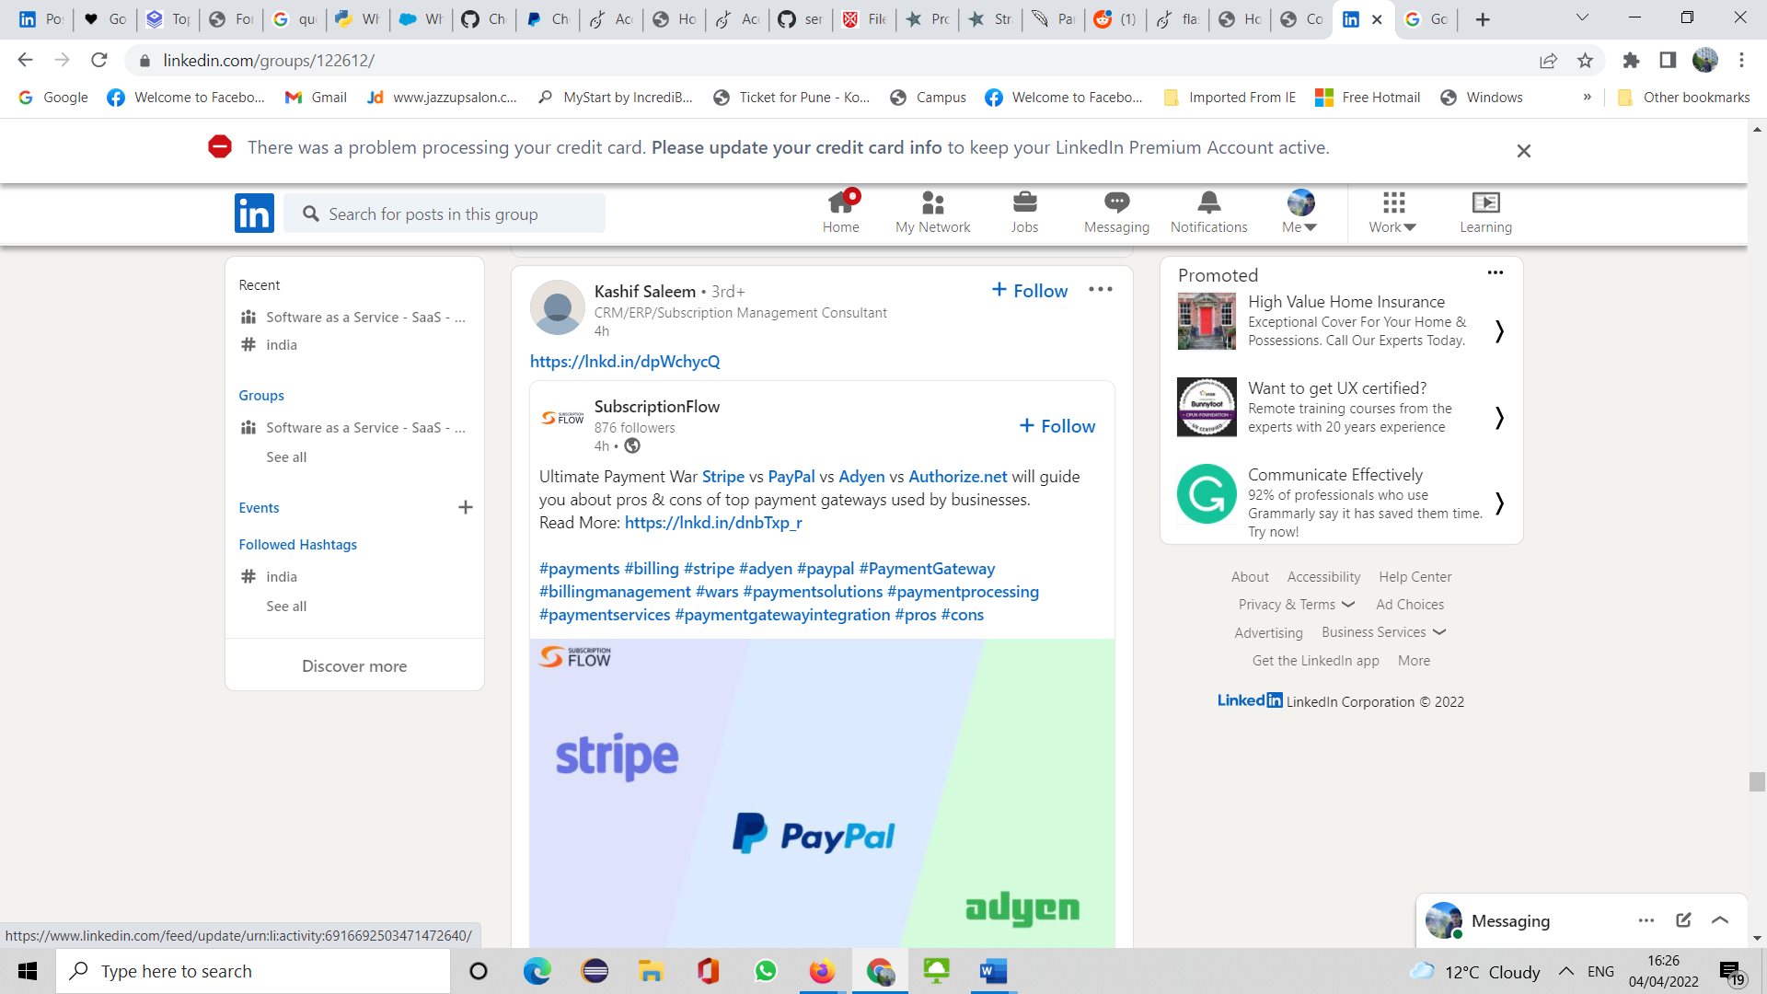

When I was going through the Posts on this Group, they get quite a lot of Views and Reach as-

1)It has 140,000 members roughly with many people trying to sell their ideas and get a wider reach.

2) It is a Group that promotes SaaS so it Will be a perfect place to display my skills

3) I saw a few similar posts like attached below, they usually have a a brief intro and attach a catchy picture and just add the links to their own Blog Posts, I will also do something similar by creating a catchy picure and writing a brief about my project and adding the links to my Blog Post page.

4) People Also post links to join their courses trying to sell their course rather than the service these posts are negatively liked by people as it is more focused towards the service rather than the courses that people are trying to sell.

5) I have also added my linked In and the link to the github Folder of my source code on github so people can access it

Testing

My working code has been tested evidently in my How-To-Guide for the Basic Flask web page and the Database connection by Attaching the Screenshots for the same , I have added the testing for the google login in the format of a screen recording to check If it working. There is one error in this project that you can’t logout after you have signed in if youre using a signed in google chrome.

This was my journey from not knowing what flask is and get a working web page with google login and paypal checkout button, unfortunately the PayPal subscription is not yet working but I will definitely get it working with the summer also maybe extend the project more.\

**Summary-**

**SaaSwebapplication**

Create a Commercial software as a service web application with user accounts and subscription service

**Google Login**

This code can be simply copied and pasted to your code by making a few changes and you will be able to get the Google Login Woking

**Basic Flask Website**

This is a perfect Service as it provides you the perfect starter Page with basic functonalities which you can start using for your future project and not waste time on creating the base , as you can just copy and paste the base.

**It has a Working database connection**

You also have a Database connection which you can use for various purposes for storing details like orders and access it

**The future goal**

The future goal is to Get the PayPal Subscription Plan Working and will be soon Updated.